**Project Development Phase**

**Model Performance Test**

|  |  |
| --- | --- |
| Date | 24 November 2023 |
| Team ID | Team ID: 591739 |
| Project Name | Restaurant Recommended System |
| Maximum Marks | 10 Marks |

**Model Performance Testing:**

In our Unsupervised Machine Learning-based restaurant recommendation project, we implemented two distinct recommendation systems:

1. A Content-Based Recommendation System, leveraging cosine similarity to analyze and recommend restaurants based on features such as location, rating, reviews, and restaurant type.
2. A Popularity-Based Recommendation System, which recommends restaurants based on their overall popularity.

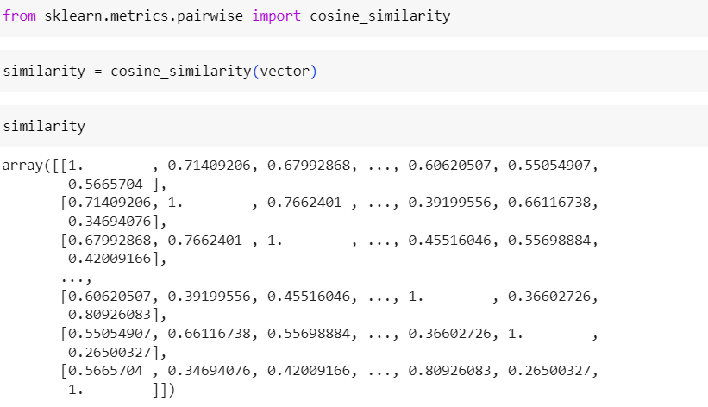

**Popularity Based Model:**

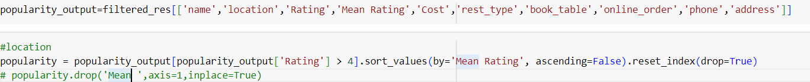

**This model takes the user input’s**

1. Recommendation based on only Restaurant Name.
2. Recommendation based on only Location.
3. Recommendation based on only Restaurant Name and Location
4. Recommendation based on only Restaurant Type and Location.

**Model Output:**

